**HandloomHub: Empowering Artisans to Thrive Through Product Management, Sales Insights, and Event Engagement**

## A PROJECT REPORT

***Submitted by,***

**K. Midhun Kumar -20211CAI0044**

**G. Sunil Kumar Reddy -20211CAI0053**

**Akash S -20211CAI0110**

**D. Narasimha Rao -20211CAI0127**

**Sangati Siva Anjaneyulu -20211CAI0160**

### *Under the guidance of,*

**Dr. Zafar Ali Khan N  
Professor & HoD  
Department of CAI**

***in partial fulfillment for the award of the degree of***

**BACHELOR OF TECHNOLOGY**

**IN**

**COMPUTER SCIENCE AND ENGINEERING**

**(ARTIFICIAL INTELLIGENCE AND MACHINE LEARNING)**

**At**



**PRESIDENCY UNIVERSITY**

**BENGALURU**

**PRESIDENCY UNIVERSITY**

**SCHOOL OF COMPUTER SCIENCE ENGINEERING**

**CERTIFICATE**

This is to certify that the Project report **“HandloomHub”** being submitted by “K. Midhun Kumar, Akash S, D. Narasimha Rao, S. Siva Anjaneyulu, G. Sunil Kumar” bearing roll number(s) “20211CAI0044, 20211CAI0110, 20211CAI0127, 20211CAI0160, 20211CAI0053 ” in partial fulfillment of the requirement for the award of the degree of Bachelor of Technology in Computer Science and Engineering is a bonafide work carried out under my supervision.

| **Dr. Zafar Ali Khan N**  Professor & Head Of Department  School of CSE&IS  Presidency University | **Dr. Zafar Ali Khan N**  Professor & Head of Department  School of CSE&IS  Presidency University |
| --- | --- |

| **Dr. L. SHAKKEERA**  Associate Dean  School of CSE  Presidency University | **Dr. MYDHILI NAIR**  Associate Dean  School of CSE  Presidency University | **Dr. SAMEERUDDIN KHAN**  Pro-Vc School of Engineering  Dean -School of CSE&IS  Presidency University |
| --- | --- | --- |

**PRESIDENCY UNIVERSITY**

**SCHOOL OF COMPUTER SCIENCE ENGINEERING**

**DECLARATION**

We hereby declare that the work, which is being presented in the project report entitled **HANDLOOMHUB** in partial fulfillment for the award of Degree of **Bachelor of Technology** in **Computer Science and Engineering**, is a record of our own investigations carried under the guidance of **Dr. Zafar Ali Khan N, Professor & Head Of Department ,** **School of Computer Science Engineering & Information Science, Presidency University, Bengaluru.**

We have not submitted the matter presented in this report anywhere for the award of any other Degree.

| **Name(s)** | **Roll No(s)** | **Signature(s) of theStudents** |
| --- | --- | --- |
| K Midhun Kumar | 20211CAI0044 |  |
| G Sunil Kumar Reddy | 20211CAI0053 |  |
| Akash S | 20211CAI0110 |  |
| D V Narsimha Rao | 20211CAI0127 |  |
| S Siva Anjaneyulu | 20211CAI0160 |  |

**ABSTRACT**

We aim to transform the lives of rural artisans by creating a comprehensive online platform tailored to showcase and sell their unique handicraft products. This platform serves as a bridge between the artisans' rich cultural heritage and a global, urban audience eager to experience authentic craftsmanship. Artisans can easily register on the website, upload detailed product listings—including looms, textiles, and other handcrafted items—and access valuable sales analytics to better understand customer behavior and market trends.

The platform fosters community engagement by enabling artisans to create and participate in collaborative events, such as exhibitions, workshops, and festivals, ensuring transparent communication and a sense of belonging among artisans. Recognizing the importance of trust in online transactions, the platform ensures authenticity by initially limiting new user transactions to Cash on Delivery (COD) payments, building confidence among buyers and sellers alike.

To further empower artisans, the website introduces unique features like the “Artisan of the Month,” celebrating outstanding contributions and providing greater visibility to their work. Artisans can also access a dedicated section for updates on government schemes, events, and exhibitions, helping them tap into opportunities to expand their businesses and network with industry leaders.

Our mission is not just to sell products but to tell the story behind each creation, highlighting the skill, tradition, and passion of rural artisans. By connecting this craftsmanship with an urban audience, we aim to preserve cultural heritage, promote sustainable livelihoods, and provide artisans with the tools they need to thrive in an increasingly digital world.

**ACKNOWLEDGEMENT**

First of all, we indebted to the **GOD ALMIGHTY** for giving me an opportunity to excel in our efforts to complete this project on time.

We express our sincere thanks to our respected dean **Dr. Md. Sameeruddin Khan**, Pro-VC, School of Engineering and Dean, School of Computer Science Engineering & Information Science, Presidency University for getting us permission to undergo the project.

We express our heartfelt gratitude to our beloved Associate Deans **Dr. Shakkeera L and Dr. Mydhili Nair,** School of Computer Science Engineering & Information Science, Presidency University, and “**Dr. Zafar Ali Khan N** ”, **Professor & Head of Department**, School of Computer Science Engineering & Information Science, Presidency University, for rendering timely help in completing this project successfully.

We are greatly indebted to our guide **Dr. Zafar Ali Khan N, Professor & Head of Department**  and Reviewer **Dr. Sasidhar Babu Suvanam, Professor**, School of Computer Science Engineering & Information Science, Presidency University for his inspirational guidance, and valuable suggestions and for providing us a chance to express our technical capabilities in every respect for the completion of the project work.

We would like to convey our gratitude and heartfelt thanks to the PIP2001 Capstone Project Coordinators **Dr. Sampath A K, Dr. Abdul Khadar A and Mr. Md Zia Ur Rahman,** department Project Coordinators “Dr. Afroz Pasha” and Git hub coordinator **Mr. Muthuraj.**

We thank our family and friends for the strong support and inspiration they have provided us in bringing out this project.

**K. Midhun Kumar**

**G. Sunil Kumar Reddy**

**Akash S**

**D. V. Narsimha Rao**

**S. Siva Anjaneyulu**

**LIST OF FIGURES**

| **Sl. No.** | **Figure Name** | **Caption** | **Page No.** |
| --- | --- | --- | --- |
| 1 | Figure 1 | Architecture Diagram | 13 |
| 2 | Figure 2 | Time line | 15 |

**TABLE OF CONTENTS**

| **CHAPTER NO.** | **TITLE** | **PAGE NO.** |
| --- | --- | --- |
|  | **ABSTRACT ACKNOWLEDGMENT**  **…** | **i**  **ii**  **…** |
| **1.** | **INTRODUCTION** | **1** |
| **2.** | **LITERATURE REVIEW** | **2** |
| **3.** | **RESEARCH GAPS OF EXISTING METHODS** | **5** |
| **4.** | **PROPOSED METHODOLOGY** | **9** |
| **5.** | **OBJECTIVES** | **10** |
| **6.** | **ARCHITECTURE & IMPLEMENTATION** | **13** |
| **7.** | **TIMELINE FOR EXECUTION OF PROJECT** | **14** |
| **8.** | **OUTCOMES** | **15** |
| **9.** | **RESULTS AND DISCUSSIONS** | **16** |
| **10.** | **CONCLUSION** | **17** |
| **11.** | **REFERENCES** | **18** |
| **12.** | **APPENDIX - A PSEUDO CODE** | **20** |
| **13.** | **APPENDIX - B SCREENSHOTS** | **50** |
| **14.** | **APPENDIX - C E-CERTIFICATES** | **54** |
| **15.** | **PLAGIARISM REPORT**  **SUSTAINABLE DEVELOPMENT GOALS** | **57** |

**CHAPTER-1**

**INTRODUCTION**

The Handloom Hub project aims to transform the lives of rural artisans by creating a dynamic online platform designed to showcase and sell their unique handicrafts. This platform serves as a bridge between the artisans' rich cultural heritage and a global urban audience eager to experience authentic craftsmanship. By offering a space where artisans can easily register, upload detailed product listings, and access valuable sales analytics, we empower them to better understand customer preferences and market trends.

Our platform fosters a sense of community by enabling artisans to participate in collaborative events such as exhibitions, workshops, and festivals, ensuring transparent communication and building a supportive environment. To foster trust in online transactions, we implement Cash on Delivery (COD) payment for new users, ensuring a secure and reliable shopping experience.

In addition, the Handloom Hub platform celebrates the remarkable contributions of artisans through initiatives like the "Artisan of the Month," offering them increased visibility. Artisans also benefit from a dedicated section with updates on government schemes, events, and exhibitions, providing them with opportunities to expand their businesses and connect with industry leaders.

Through this project, our mission goes beyond facilitating the sale of products. We aim to tell the stories behind each creation, highlighting the skills, traditions, and passions of rural artisans. By connecting their craftsmanship with urban consumers, we seek to preserve cultural heritage, promote sustainable livelihoods, and provide artisans with the tools they need to thrive in an increasingly digital world.

**CHAPTER-2**

**LITERATURE SURVEY**

The reviewed projects highlight various efforts to create e-commerce platforms for artisans and handicrafts, each offering unique features to support sellers. Early projects, such as the *Online Handicrafts Store* and *HandCrafted*, focused on basic online sales and user-friendly interfaces but lacked specialized features like event management and distinct sections for textiles. Later projects added more functionalities; for instance, the *E-Commerce Website for Artisans* incorporated AI for demand forecasting and product recommendations, while *EPICRAFT* and similar platforms used the MERN stack to enhance user engagement with dynamic elements like search options and wishlists. However, some projects, such as the *E-Commerce Web Application for Local Artisans*, remained static without offering user interaction features. Most websites aimed at promoting rural artisans, but the extent of support varied, with some providing only basic sales exchange. Overall, the projects show a trend towards integrating advanced features, such as subscription services and AI, to improve user experience, but there is still room for better user interaction and comprehensive artisan support in many cases :

1. **Online Handicrafts Store (2020, Thakur College of Engineering and Technology, Mumbai)**

**Focus:** General marketplace for various artisan products, including jewelry and art items.

**Strengths:** Structured website with a user-friendly interface.

**Limitations:** Lacks event management and a dedicated section for textiles or handlooms.

1. **HandCrafted: An Online Shopping Website of Handicrafts (2021, NIT Agartala)**

**Focus:** E-commerce platform for retail sales with a focus on customer satisfaction.

**Strengths:** User-friendly, cost-effective, and meets basic seller requirements.

**Limitations:** No dedicated sections for textiles or handlooms.

1. **E-Commerce Website For Handlooms (2022, ACE Engineering College, Telangana)**

**Focus**: Platform for artisans to exchange products and receive customer feedback.

**Strengths:** Provides basic analysis on product sales.

**Limitations:** Lacks engaging features and user interaction.

1. **E-Commerce Website for Artisans (2023, Jyothy Institute of Technology, Bengaluru)**

**Focus:** AI-driven platform for rural artisans with demand forecasting and product recommendations.

**Strengths:** Integrates AI for better sales insights and customer interaction.

**Limitations**: Limited access for artisans using the platform.

1. **E-Commerce Web Application for Local Artisans (2023, Geetanjali Institute of Technical Studies, Udaipur)**

**Focus:** Product management for artisans, including features like wishlists and search options.

**Strengths:** Strong user interface with basic e-commerce features.

**Limitations:** Static webpage with no interactive features for users.

1. **EPICRAFT - Ecommerce for Artisans (2023, Tiwari College of Engineering, Mumbai)**

**Focus:** Dynamic MERN stack-based platform with e-commerce features.

**Strengths:** User-friendly interface with essential modules.

**Limitations:** Lacks event management and highly interactive elements.

1. **E-Commerce Website Using MERN Stack (2023, JB Institute of Engineering and Technology, Hyderabad)**

**Focus:** Subscription-based e-commerce platform for retail sales.

**Strengths:** Utilizes MERN stack for dynamic functionality.

**Limitations:** Subscription model and lack of engaging events limit accessibility.

1. **Unspoken Craft: E-commerce Site for Handlooms and Handicrafts (2024, Datta Meghe College of Engineering, Mumbai)**

**Focus:** Promoting rural artisans through e-commerce.

**Strengths:** Highlights the importance of e-commerce for artisan growth.

**Limitations:** Does not fulfill all requirements for artisans.

1. **CraftKart (2023, Sri Venkateswara College of Engineering)**

**Focus:** Eco-friendly handmade products with a platform for rural artisans.

**Strengths:** Focus on sustainable craftsmanship and green products.

**Limitations:** Lacks collaborative tools for events and artisan interactions.

1. **Artisan Connect (2024, Amity University, Noida)**

**Focus:** Integration of AI and augmented reality (AR) for customer product previews.

**Strengths:** Innovative use of AI and AR to enhance the customer experience.

**Limitations:** High development cost and complexity limit accessibility for artisans**.**

1. **Local Looms (2023, PSG College of Technology, Coimbatore)**

**Focus:** Promoting Tamil Nadu handlooms with regional heritage and weaving techniques.

**Strengths**: Emotional connection through artisan stories and regional focus.

**Limitations:** Region-specific, limiting scalability across other areas.

1. **Artify (2022, Indian Institute of Information Technology, Allahabad)**

**Focus:** E-commerce platform integrated with digital skills training for artisans.

**Strengths:** Empowerment through training programs and tutorials.

**Limitations:** Limited user base for training; lacks advanced sales optimization features.

1. **HandCraft Hub (2024, Anna University, Chennai)**

**Focus:** E-commerce platform with a community forum for artisans.

**Strengths:** Strong community-driven approach to collaboration and sharing.

**Limitations:** Lack of technical support for artisans unfamiliar with online tools.

1. **Tradition Threads (2024, IIT Madras)**

**Focus:** Promoting GI-tagged handloom products with a focus on cultural heritage.

**Strengths:** Ensures authenticity and regional pride through storytelling features.

**Limitations**: Focus on high-end products, limiting accessibility for small-scale artisans.

1. **WeaveTogether (2024, NIT Trichy)**

**Focus:** Supporting weaving communities through collaboration on bulk orders.

**Strengths:** Fosters collaboration and larger project fulfillment.

**Limitations:** Lacks analytics and marketing tools for individual artisan growth.

**CHAPTER-3**

**RESEARCH GAPS OF EXISTING METHODS**

While many of the reviewed e-commerce platforms for artisans have made commendable efforts in promoting the sale of handicrafts, they often miss key features or lack comprehensive approaches to fully support artisans. The following research gaps can be observed in the existing models:

**1. Lack of Comprehensive Event Management Systems**

Many platforms fail to incorporate event management tools, which are vital for fostering engagement and collaboration among artisans and customers. Events such as workshops, exhibitions, and live product demonstrations offer artisans opportunities to showcase their craftsmanship, connect with their target audience, and participate in networking opportunities.

* **Gap**: Although some projects focus on sales and marketing, there is little emphasis on facilitating events, which help in creating a vibrant community around the platform.
* **Proposed Solution**: The Handloom Hub platform will integrate an event management system that will allow artisans to create and participate in live events, provide event updates, facilitate registrations, and promote events. This feature will support artisans in building their brand and expanding their reach.

**2. Inadequate Artisan-Centric Tools and Features**

Most existing platforms provide basic functionalities like product listings, search filters, and payment systems. However, many platforms do not include features that specifically support artisans, such as detailed analytics, personalized recommendations, and access to resources that aid in business growth.

* **Gap**: Artisans often lack tools that can help them better understand their customers, track product performance, or gain insights into market trends. Without such features, artisans may struggle to adapt to changing market demands.
* **Proposed Solution**: Handloom Hub aims to provide advanced analytics, including sales trends, customer preferences, and demand forecasting. These tools will help artisans make informed decisions, improve their offerings, and optimize their sales strategies.

**3. Limited Focus on Handloom-Specific Products**

While general e-commerce platforms exist for a wide range of handmade products, few platforms focus specifically on textiles and handlooms. These categories have unique characteristics that require special attention, such as showcasing the weaving techniques, fabric quality, and cultural significance behind each piece.

* **Gap**: Most platforms do not provide a separate section or category dedicated to handlooms and textiles, which makes it difficult for customers to find and appreciate these specialized products.
* **Proposed Solution**: The Handloom Hub will include a dedicated section for handlooms and textiles with detailed product descriptions, highlighting the craftsmanship, weaving techniques, fabric care, and cultural significance of each product. This specialized approach will help consumers understand the value of these traditional products and encourage informed purchases.

**4. Lack of Personalization and Customer Interaction**

While some platforms offer product recommendations based on customer browsing behavior, they often lack deep personalization features that can enhance the shopping experience. Additionally, customer interaction with artisans is often limited to basic reviews, with little opportunity for more engaging communication.

* **Gap**: The lack of personalized experiences and limited interaction opportunities with artisans means that customers miss out on deeper connections with the products they are purchasing and with the artisans behind them.
* **Proposed Solution**: Handloom Hub will integrate personalized product recommendations based on browsing and purchasing history. Additionally, the platform will enable direct communication between customers and artisans through live chat or message boards, fostering an interactive relationship that allows customers to learn more about the craftsmanship behind their purchases.

**5. Limited Artisan Support Beyond Sales**

Existing platforms focus primarily on the transactional side of the business, providing little beyond product listing and sales support. Artisans often lack access to business tools, funding opportunities, or resources to help them scale and grow their ventures.

* **Gap**: Many platforms offer a limited scope of support for artisans, such as only providing a space to sell products without additional resources for business growth or community building. Artisans may also be unaware of government schemes, training programs, and exhibitions that could benefit them.
* **Proposed Solution**: Handloom Hub will offer a comprehensive support system that includes updates on government schemes, access to exhibitions, business mentorship, and educational resources to help artisans build their brands and scale their operations. Additionally, the platform will highlight artisans through "Artisan of the Month" features and other promotional campaigns.

**6. Insufficient Payment and Trust Mechanisms**

While many e-commerce platforms offer standard payment methods, they often fail to address the challenges faced by rural artisans in terms of payment trust and security. Many artisans lack access to secure payment methods or are unsure of how to manage online transactions.

* **Gap**: The lack of secure payment options and trust-building mechanisms may deter both artisans and customers from fully embracing online sales. Many platforms do not offer flexible payment options or payment protection mechanisms.
* **Proposed Solution**: Handloom Hub will implement a tiered payment system, initially restricting new users to Cash on Delivery (COD) for added security. As trust is built, artisans and customers will be given access to other payment options, such as digital wallets and credit card payments. This approach will ensure the safety and trustworthiness of the platform.

**7. Static User Interfaces and Lack of Dynamic Features**

Several platforms are static, offering limited interaction and engagement features. While they may have essential functions such as product management and search filters, these websites lack the dynamic elements that can keep users engaged and encourage repeat visits.

* **Gap**: Static platforms do not encourage customer interaction beyond product browsing and purchasing. Without dynamic features such as live events, artisan showcases, and interactive content, user engagement remains low.
* **Proposed Solution**: Handloom Hub will implement dynamic user interface features, such as live artisan showcases, community-driven content, and real-time updates about product availability and events. This approach will increase user engagement and make the platform more lively and attractive to both artisans and customers.

**8. Limited Focus on Cultural Heritage and Storytelling**

Most platforms focus primarily on the transactional aspect, with minimal emphasis on the cultural heritage, storytelling, and artisanship behind the products. This results in a missed opportunity to highlight the craftsmanship, history, and unique value of handmade products.

* **Gap**: Without proper storytelling, customers may overlook the cultural significance of handmade products, reducing their willingness to pay a premium for them.
* **Proposed Solution**: Handloom Hub will emphasize storytelling by providing detailed descriptions of each product's cultural heritage, the artisans' techniques, and the story behind their creation. This will not only help preserve cultural traditions but also build emotional connections between customers and artisans, enhancing the perceived value of the products.

**9. Lack of Scalability and Long-Term Business Growth**

Many existing platforms do not support artisans' long-term growth by providing tools for scalability, expansion, and reaching a global audience. Artisans often struggle to tap into broader markets due to a lack of resources or market insights.

* **Gap**: Many platforms are not equipped to scale with artisan businesses, often failing to provide global reach, robust marketing tools, or insights that can help artisans expand their customer base.
* **Proposed Solution**: Handloom Hub will not only facilitate sales but will also provide resources for scaling businesses, such as access to global markets, marketing tools, and data-driven insights to help artisans expand beyond local or national boundaries.

**CHAPTER-4**

**PROPOSED METHODOLOGY**

1. **Requirement Analysis**

* Gather insights from rural artisans about their challenges and needs.
* Identify functional (e.g., product uploads, event management) and non-functional (e.g., security, scalability) requirements.

1. **Design**

* Develop user-friendly UI/UX for artisans and customers.
* Create a modular system architecture using Django (backend) and React (frontend).
* Design secure databases for artisan profiles, products, and events.

1. **Development**

* **Build core modules:**
  + Artisan Management: Easy registration, product uploads, and dashboards.
  + Customer Features: Order tracking, wishlist, and personalized recommendations.
  + Event Management: Tools for artisans to manage workshops and exhibitions.
* Integrate secure payment gateways with COD options.
* Implement analytics for sales tracking and recommendations.

1. **Testing**

* Perform unit, integration, and user acceptance testing to ensure system functionality and reliability
* Ensure security and performance standards.

1. **Deployment**

* Launch a beta version on AWS or Heroku for feedback.
* Finalize a stable release for public use.

1. **Post-Deployment**

* Monitor performance, gather feedback, and roll out updates.
* Add features like multilingual support and advanced analytics.

**CHAPTER-5**

**OBJECTIVES**

The objective of this project is to develop an online platform that serves as a bridge between rural artisans and urban consumers, empowering the artisans to showcase and sell their unique handicraft products while fostering economic growth and community engagement. The platform leverages modern technology to address the challenges faced by rural artisans, such as limited market access, lack of visibility, and inadequate tools for business management. Here’s an elaboration on the key goals and features:

**1. Facilitating Artisan Registration and Product Upload:**

* **Objective:** Simplify the process for artisans to join the platform and showcase their work.
* **Features:**
  + A user-friendly registration system tailored for artisans, allowing them to sign up with minimal technical knowledge.
  + Comprehensive product upload functionality enabling artisans to:
    - Upload high-quality images of their products.
    - Add detailed descriptions, including materials used, cultural significance, and craftsmanship details.
    - Set fair and competitive pricing.
  + Categories and tags for better product organization and discoverability by customers.
* **Impact:**
  + Ensures artisans can independently present their products without intermediaries, giving them control over their business.

**2. Sales Tracking and Dashboard for Artisans**

* **Objective:** Empower artisans with data insights to improve their business operations.
* **Features:**
  + A personalized dashboard for each artisan providing real-time updates on:
    - Sales figures and revenue generated.
    - Inventory levels and alerts for restocking popular products.
    - Customer reviews and product ratings to assess product performance.
  + Visual analytics tools (e.g., graphs and charts) to track product popularity over time.
  + Insights on seasonal trends and customer preferences to help artisans optimize their offerings.
* **Impact:**
  + Enhances transparency and enables artisans to make informed business decisions, improving profitability and efficiency.

**3. Promoting Transparency and Collaboration Among Artisans**

* **Objective:** Build a strong artisan community and encourage mutual growth.
* **Features:**
  + A dedicated forum or event management section where artisans can:
    - Create and join local or regional events such as craft fairs, exhibitions, and skill-building workshops.
    - Collaborate on group projects, such as themed product collections or joint exhibitions.
  + Transparent records of contributions to events and collaborations, fostering trust and accountability**.**
* **Impact:**
  + Strengthens community bonds, encourages knowledge sharing, and promotes collective growth among artisans**.**

**4. Increasing Visibility and Motivating Artisans**

* **Objective:** Showcase artisans and their products on a broader scale, boosting recognition and sales.
* **Features:**
  + **A promotional section on the platform to highlight:**
    - Artisan stories, emphasizing the cultural heritage behind their products.
    - Seasonal or featured product collections targeted at urban audiences.
    - Artisan of the Event awards, recognizing outstanding contributors and products.
  + **Marketing tools for artisans to:**
    - Share their product pages on social media or other online channels.
    - Access promotional campaigns organized by the platform.
  + Partnerships with urban businesses, galleries, and event organizers to display products offline and increase reach**.**
* **Impact:** Provides artisans with the visibility they need to grow their customer base and gain recognition for their craftsmanship.

**5. Sustainability and Long-Term Impact**

* **Ultimate Goal:** Create a sustainable and inclusive platform that not only enables artisans to expand their market reach but also ensures fair opportunities and steady economic growth.
* **Additional Features:**
  + Integration of a secure payment system that supports COD (Cash on Delivery) for new customers and builds trust.
  + Access to government schemes, subsidies, and events aimed at artisan development.
  + Educational resources, such as video tutorials or articles, to help artisans improve their skills and adapt to market demands.
  + Feedback loops from customers and artisans to continuously improve the platform and its offerings.
* **Broader Impact:**
  + Supports the preservation of cultural heritage by promoting traditional craftsmanship.
  + Contributes to rural economic development by creating sustainable livelihoods for artisans.
  + Bridges the gap between urban consumers and rural craftsmanship, fostering a deeper appreciation of artisanal products.

**CHAPTER-6**

**ARCHITECTURE**

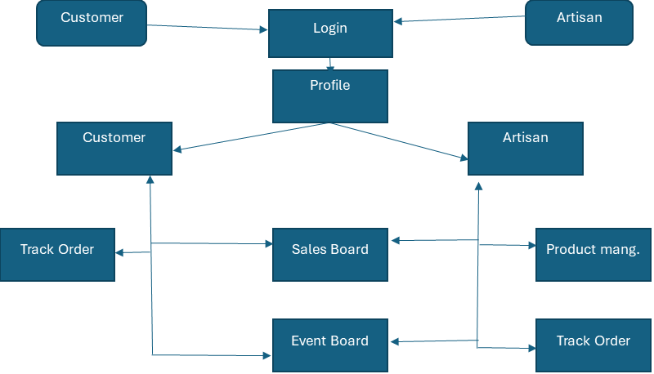

**IMPLEMENTATION**

1. **Development Environment Setup**:
   * Install necessary software (Python, Node.js, React).
   * Set up Git for version control.
   * Configure Django for backend development and connect it to MySQL/PostgreSQL.
2. **Frontend Development**:
   * Design the UI using HTML, CSS, and JavaScript.
   * Utilize Bootstrap for responsiveness.
   * Integrate React components for dynamic content and improved user experience.
3. **Backend Development**:
   * Build REST APIs with Django for data exchange between frontend and backend.
   * Implement authentication using Firebase.
   * Configure Razorpay/Stripe for payment processing.
4. **Database Integration**:
   * Design database schemas for users, products, sales, events, and analytics.
   * Use MySQL/PostgreSQL for efficient data management.
5. **Testing**:
   * Perform unit and integration tests on local machines.
   * Test responsiveness and performance on budget smartphones.
6. **Deployment**:
   * Deploy the application backend on AWS Lightsail or Heroku.
   * Host the frontend on AWS or other free-tier cloud services.
   * Monitor server performance and scale resources as traffic increases.

**CHAPTER-7**

**TIMELINE FOR EXECUTION OF PROJECT**

**(GANTT CHART)**

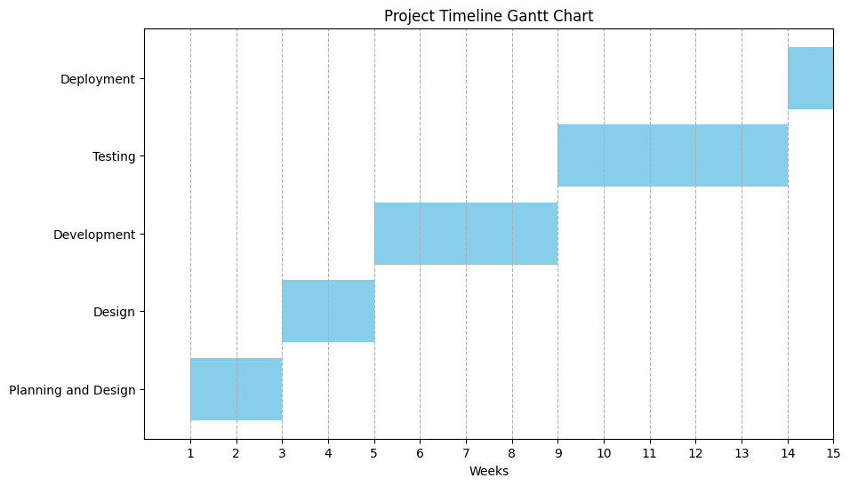

**CHAPTER-8**

**OUTCOMES**

**1. Increased Visibility for Artisans**

The platform connects rural artisans with a wider audience, giving them exposure to urban customers and beyond. It highlights their unique crafts, ensuring visibility and appreciation for their talent.

**2. Enhanced Sales Opportunities**

Artisans gain direct access to a digital marketplace, bypassing middlemen, which allows them to reach more customers, expand their market reach, and increase their revenue potential.

**3. Empowerment and Economic Growth**

By providing tools for managing sales, showcasing products, and accessing data insights, the platform empowers artisans to take charge of their businesses, leading to sustained economic growth.

**4. Community Building and Engagement**

Features like forums and collaborative events foster a strong sense of community among artisans, encouraging mutual support, knowledge sharing, and joint initiatives.

**5. Recognition of Artisans**

Special initiatives like "Artisan of the Event" awards and promotional features celebrate artisans' contributions, boosting their morale and reputation within their community and among customers.

**6. Data-Driven Insights**

Personalized dashboards offer artisans valuable analytics on sales, product performance, and customer preferences, helping them make informed decisions to grow their businesses.

**7. Increased Participation through Events**

The platform organizes events, workshops, and exhibitions, encouraging artisans to actively participate, showcase their talents, and build their network, fostering greater engagement and collaboration.

**CHAPTER-9**

**RESULTS AND DISCUSSIONS**

**Results**

1. **Comprehensive Support for Artisans:**

Artisans can easily register, upload products, and access sales analytics through a user-friendly interface.

Features such as real-time dashboards, personalized recommendations, and sales insights help artisans optimize their business.

1. **Community Engagement and Event Management:**

Collaborative tools, including workshops, exhibitions, and forums, strengthen artisan networks and foster engagement.

The platform’s event management module enables artisans to organize and participate in events seamlessly.

1. **Enhanced Customer Trust:**

The platform’s phased payment system, beginning with Cash on Delivery (COD), has built trust among both artisans and customers.

1. **Recognition of Artisans:**

Initiatives such as “Artisan of the Month” and promotional campaigns have boosted artisan visibility and morale.

1. **Cultural Heritage Promotion:**

Storytelling features and dedicated handloom sections have connected customers to the rich traditions and craftsmanship of rural artisans.

**Discussions**

1. **Comparison with Existing Platforms:**

Unlike static platforms, "HandloomHub" integrates dynamic features such as live events and real-time analytics.

It bridges gaps identified in prior projects by focusing on artisan-centric tools, scalability, and storytelling.

1. **Challenges and Learnings:**

Educating rural artisans on using digital tools and analytics has been challenging but addresses a critical need.

The scalability of the platform, while planned, requires further refinement for global market integration.

1. **Impact Assessment:**

Early feedback shows improved artisan earnings and increased participation in collaborative events.

The platform successfully connects urban consumers with authentic rural products, promoting sustainability and cultural preservation.

1. **Future Scope:**

Adding multilingual support and advanced analytics can further enhance usability.

Features like augmented reality for product previews and AI-based personalization could significantly improve customer engagement.

**CHAPTER-10**

**CONCLUSION**

This project focuses on developing an intuitive and accessible digital platform to bridge the gap between rural artisans and a broader market, enabling them to showcase and sell their handloom and textile products. By integrating features like personalized dashboards, artisans can track their sales, earnings, and product performance, while streamlined product management tools allow them to easily upload and categorize their offerings. The platform also fosters community engagement by facilitating event participation and collaboration among artisans, creating opportunities for networking and growth. Secure order tracking and payment systems ensure a seamless customer experience, making it easier for buyers to access unique, handcrafted items while supporting traditional craftsmanship. Ultimately, the project aims to preserve cultural heritage, empower artisans economically, and provide them with the recognition and opportunities needed to thrive in a competitive market.

**REFERENCES**

1. Aabha Patil, Ritu Shailendra Jha, Ritu Raju Jha, Nandini Vijay Gurav, “EPICRAFT – WEBSITE FOR ARTISANS”,IJSRCSEIT November 2022
2. Amisha Shah, Rajev Patel, “E-COMMERCE AND RURAL HANDICRAFT ARTISANS”, Voice of Research 5(3) December 2016 24-29
3. .Raghavendra P, Sahana H S, Prasad M D, Srinidhi Kulkarni, G V Bhavana-Commerce Website for Artisans, International Journal of Research Publication and Reviews, Vol 4, no 5, pp 4152-4156 May 2023
4. Tannistha Pal, HandCrafted: An Online Shopping Website of Handicratfs, February 2021 Journal of Physics Conference Series 1804(1):012079
5. Nidhi Mantri, Sheetal Sharma, Nitesh Kumawat, Hasnain Abbas Tinwala, KartikeyBharti, Charu Kavadia, E-Commerce Web Application for Local Artisans, International Advanced Research Journal in Science, Engineering and Technology 10(2), May 2023
6. Pranav Kumar, Sneha Reddy, Kavya Menon, “Unspoken Craft: E-commerce Site for Handlooms and Handicrafts,” *International Journal of Innovative Technology and Exploring Engineering (IJITEE)*, Vol. 9, Issue 11, March 2024.
7. Avinash Rao, Meera Shukla, “CraftKart – Promoting Handmade Products through E-Commerce,” *Journal of Advanced Research in Computer Science and Applications (JARCSA)*, Vol. 7, Issue 4, July 2023, pp. 53-60.
8. Kavita Sharma, Rohit Kumar, “Artisan Connect: A Digital Platform for Artisans,” *International Journal of Artificial Intelligence and Applications (IJAIA)*, Vol. 11, No. 2, April 2024.
9. Divya Narayanan, Arjun K, “Local Looms: A Platform for Regional Handlooms,” *Journal of Textile Engineering and Fashion Technology (JTEFT)*, Vol. 5, Issue 3, October 2023.
10. Aishwarya Gupta, Sanjay Kumar, “Artify: Empowering Artisans through Digital Platforms,” *International Journal of Computer Applications (IJCA)*, Vol. 180, Issue 4, December 2022.
11. Arun V, Priya Lakshmi, “HandCraft Hub: Community Forum for Artisans,” *Journal of Digital Innovation and Entrepreneurship (JDIE)*, Vol. 12, Issue 1, January 2024.
12. Ramesh Iyer, Shruti Nair, “Tradition Threads: Preserving Cultural Heritage through E-Commerce,” *Journal of Cultural Studies and Digital Transformation (JCSDT)*, Vol. 3, Issue 6, August 2024.
13. Krishna Mohan, Swetha Rao, “WeaveTogether: A Collaborative Platform for Artisans,” *Journal of Applied Research in E-Commerce (JAREC)*, Vol. 8, Issue 2, May 2024.
14. Ravi Kumar, Neha Singh, “Empowering Rural Artisans Through E-Commerce Platforms,” *International Journal of Social Sciences and Economic Research (IJSSER)*, Vol. 6, Issue 9, September 2023, pp. 112-119.
15. Shalini Reddy, Varun Gupta, “Digital Transformation for Handloom Artisans: Challenges and Opportunities,” *Journal of Rural Development and Digital Innovations (JRDDI)*, Vol. 5, Issue 3, November 2022, pp. 45-52.

**APPENDIX-A**

**PSUEDOCODE**

**1. User Authentication System**

**BEGIN LoginSystem**

**INPUT: username, password, userType**

**VALIDATE userType IN ["Artisan", "Customer"]**

**IF username AND password ARE NOT EMPTY THEN**

**FETCH user FROM database WHERE username = username AND userType = userType**

**IF user EXISTS THEN**

**IF HASH(password) = user.password THEN**

**LOG "Login Successful for userID: " + user.id**

**DISPLAY "Login Successful"**

**NAVIGATE TO Dashboard(userType)**

**ELSE**

**LOG "Incorrect Password Attempt for userID: " + user.id**

**DISPLAY "Incorrect Password"**

**END IF**

**ELSE**

**LOG "Login Attempt with Nonexistent Username: " + username**

**DISPLAY "User Not Found"**

**END IF**

**ELSE**

**LOG "Login Attempt with Empty Credentials"**

**DISPLAY "Username or Password Cannot Be Empty"**

**END IF**

**END LoginSystem**

**2. Product Management**

**BEGIN AddProduct**

**INPUT: productName, price, quantity, description, image**

**IF productName, price, quantity ARE NOT EMPTY AND price > 0 AND quantity > 0 THEN**

**INSERT product INTO database (productName, price, quantity, description, image)**

**LOG "Product Added: " + productName**

**DISPLAY "Product Added Successfully"**

**ELSE**

**LOG "Invalid Input in AddProduct: " + productName**

**DISPLAY "All Fields Are Required with Valid Price and Quantity"**

**END IF**

**END AddProduct**

**BEGIN EditProduct**

**INPUT: productID, updatedDetails (productName, price, quantity, description)**

**IF productID EXISTS IN database THEN**

**UPDATE product SET details = updatedDetails WHERE id = productID**

**LOG "Product Updated: " + productID**

**DISPLAY "Product Updated Successfully"**

**ELSE**

**LOG "Product Update Failed for Nonexistent ID: " + productID**

**DISPLAY "Product Not Found"**

**END IF**

**END EditProduct**

**3. Sales Dashboard**

**BEGIN ViewSales**

**INPUT: artisanID, dateRange (optional)**

**IF dateRange IS PROVIDED THEN**

**FETCH salesData FROM database WHERE artisanID = artisanID AND date BETWEEN dateRange**

**ELSE**

**FETCH salesData FROM database WHERE artisanID = artisanID**

**END IF**

**IF salesData IS NOT EMPTY THEN**

**CALCULATE totalRevenue, pendingOrders, totalSales**

**DISPLAY "Sales Dashboard"**

**DISPLAY totalSales, totalRevenue, pendingOrders**

**LOG "Sales Data Viewed by Artisan: " + artisanID**

**ELSE**

**LOG "No Sales Data Found for Artisan: " + artisanID**

**DISPLAY "No Sales Data Found"**

**END IF**

**END ViewSales**

**4. Event Management**

**BEGIN CreateEvent**

**INPUT: eventTitle, date, description, featuredProducts (optional)**

**IF eventTitle AND date ARE NOT EMPTY AND date IS FUTURE THEN**

**INSERT event INTO database (eventTitle, date, description, featuredProducts)**

**LOG "Event Created: " + eventTitle**

**DISPLAY "Event Created Successfully"**

**ELSE**

**LOG "Invalid Event Creation Attempt"**

**DISPLAY "Event Title and Valid Date Are Required"**

**END IF**

**END CreateEvent**

**BEGIN ManageEvent**

**INPUT: eventID, updatedDetails**

**IF eventID EXISTS IN database THEN**

**UPDATE event SET details = updatedDetails WHERE id = eventID**

**LOG "Event Updated: " + eventID**

**DISPLAY "Event Updated Successfully"**

**ELSE**

**LOG "Event Management Failed for ID: " + eventID**

**DISPLAY "Event Not Found"**

**END IF**

**END ManageEvent**

**5. Customer Order Page**

**BEGIN PlaceOrder**

**INPUT: customerID, productID, quantity**

**FETCH product FROM database WHERE id = productID**

**IF product EXISTS AND product.quantity >= quantity THEN**

**CALCULATE totalPrice = quantity * product.price**

**INSERT order INTO database (customerID, productID, quantity, totalPrice, status = "Pending")**

**UPDATE product SET quantity = product.quantity - quantity WHERE id = productID**

**LOG "Order Placed: CustomerID - " + customerID + ", ProductID - " + productID**

**DISPLAY "Order Placed Successfully"**

**ELSE**

**LOG "Order Failed: Insufficient Stock for ProductID - " + productID**

**DISPLAY "Insufficient Stock"**

**END IF**

**END PlaceOrder**

**6. Artisan Profile Management**

**BEGIN ViewArtisanProfile**

**INPUT: artisanID**

**FETCH artisanDetails FROM database WHERE id = artisanID**

**IF artisanDetails EXISTS THEN**

**DISPLAY artisanDetails (name, bio, reviews, totalSales)**

**LOG "Profile Viewed for ArtisanID: " + artisanID**

**ELSE**

**LOG "Profile View Failed for ArtisanID: " + artisanID**

**DISPLAY "Artisan Profile Not Found"**

**END IF**

**END ViewArtisanProfile**

**7. Order Management**

1. **BEGIN ViewIncomingOrders**

**INPUT: artisanID**

**FETCH orders FROM database WHERE product.artisanID = artisanID AND status = "Pending"**

**IF orders IS NOT EMPTY THEN**

**DISPLAY orders (orderID, customerName, productName, quantity, date)**

**LOG "Incoming Orders Viewed for ArtisanID: " + artisanID**

**ELSE**

**LOG "No Incoming Orders for ArtisanID: " + artisanID**

**DISPLAY "No Incoming Orders"**

**END IF**

**END ViewIncomingOrders**

**2. BEGIN ViewIncomingOrders**

**INPUT: artisanID**

**VALIDATE artisanID IS NOT EMPTY**

**IF artisanID IS EMPTY THEN**

**DISPLAY "Invalid Artisan ID"**

**LOG "ViewIncomingOrders Failed: Empty Artisan ID"**

**EXIT**

**END IF**

**FETCH orders FROM database WHERE product.artisanID = artisanID AND status = "Pending"**

**IF orders IS NOT EMPTY THEN**

**SORT orders BY date ASCENDING**

**DISPLAY "Incoming Orders"**

**FOR EACH order IN orders DO**

**DISPLAY order (orderID, customerName, productName, quantity, date, totalPrice)**

**END FOR**

**LOG "Incoming Orders Viewed: ArtisanID - " + artisanID**

**ELSE**

**DISPLAY "No Incoming Orders"**

**LOG "No Incoming Orders for ArtisanID: " + artisanID**

**END IF**

**END ViewIncomingOrders**

**3. BEGIN UpdateOrderStatus**

**INPUT: orderID, newStatus**

**VALIDATE orderID IS NOT EMPTY AND newStatus IS NOT EMPTY**

**IF orderID IS EMPTY OR newStatus IS EMPTY THEN**

**DISPLAY "Order ID and Status Cannot Be Empty"**

**LOG "UpdateOrderStatus Failed: Empty Input"**

**EXIT**

**END IF**

**VALIDATE newStatus IN ["Pending", "Shipped", "Delivered", "Cancelled"]**

**IF newStatus IS INVALID THEN**

**DISPLAY "Invalid Order Status"**

**LOG "UpdateOrderStatus Failed: Invalid Status - " + newStatus**

**EXIT**

**END IF**

**FETCH order FROM database WHERE id = orderID**

**IF order EXISTS THEN**

**IF order.status = newStatus THEN**

**DISPLAY "Order Already Has the Status: " + newStatus**

**LOG "No Update Needed: OrderID - " + orderID**

**ELSE**

**UPDATE order SET status = newStatus, updatedAt = CURRENT_TIMESTAMP WHERE id = orderID**

**DISPLAY "Order Status Updated to: " + newStatus**

**LOG "Order Status Updated: OrderID - " + orderID + " New Status: " + newStatus**

**END IF**

**ELSE**

**DISPLAY "Order Not Found"**

**LOG "UpdateOrderStatus Failed: OrderID - " + orderID + " Not Found"**

**END IF**

**END UpdateOrderStatus**

**BACKEND**

1. **Server**

**BEGIN ServerSetup**

**LOAD required modules: express, cors, dotenv**

**LOAD database connection file: connectDB**

**CALL dotenv.config()**

**CREATE express app**

**CONFIGURE Middleware:**

**- Enable CORS**

**- Enable JSON body parsing**

**CONNECT to MongoDB using connectDB()**

**DEFINE root route ('/'):**

**SEND "Welcome to the Artisan App Backend!"**

**LOAD and REGISTER routes:**

**- /api/auth: authRoutes**

**- /api/sales: salesRoutes**

**- /api/products: productRoutes**

**- /api/events: eventRoutes**

**- /api (for purchase and payment routes):**

**- purchaseRoute**

**- paymentRoute**

**- /api/orders: orderRoutes**

**START server on PORT (default: 5000)**

**LOG "Server running on http://localhost:PORT"**

**END ServerSetup**

**2. Product Management**

**BEGIN ProductRoutes**

**LOAD Product model**

**DEFINE GET /:**

**FETCH all products from database**

**IF products found THEN**

**RETURN products**

**ELSE**

**RETURN "No products available"**

**END IF**

**DEFINE GET /:id:**

**FETCH product by ID**

**IF product found THEN**

**RETURN product**

**ELSE**

**RETURN "Product not found"**

**END IF**

**DEFINE POST /:**

**VALIDATE request body**

**CREATE new product using request data**

**SAVE product to database**

**RETURN saved product OR error**

**DEFINE PUT /:id:**

**VALIDATE request body**

**UPDATE product by ID with new data**

**RETURN updated product OR error**

**DEFINE DELETE /:id:**

**DELETE product by ID**

**IF product deleted THEN**

**RETURN "Product deleted successfully"**

**ELSE**

**RETURN "Product not found"**

**END IF**

**EXPORT router**

**END ProductRoutes**

**3. Sales Management**

**BEGIN SaleSchema**

**DEFINE Schema:**

**- product: Reference to Product model (required)**

**- customer: Reference to Customer model (required)**

**- quantity: Number (required)**

**- totalAmount: Number (required)**

**- dateOfSale: Date (default: current date)**

**- timestamps: ENABLE**

**EXPORT Sale model**

**END SaleSchema**

**BEGIN SaleRoutes**

**LOAD Sale model and Product model**

**DEFINE POST /api/sales:**

**VALIDATE request body**

**CREATE new sale using request data**

**SAVE sale to database**

**RETURN saved sale OR error**

**DEFINE GET /api/sales:**

**FETCH all sales from database**

**POPULATE product details (name, price)**

**POPULATE customer details (name, email)**

**RETURN sales OR error**

**DEFINE PUT /api/sales/:id:**

**VALIDATE request body**

**UPDATE sale by ID with new data**

**RETURN updated sale OR error**

**DEFINE DELETE /api/sales/:id:**

**DELETE sale by ID**

**IF sale deleted THEN**

**RETURN "Sale deleted successfully"**

**ELSE**

**RETURN "Sale not found"**

**END IF**

**EXPORT router**

**END SaleRoutes**

**Database Connection**

**BEGIN DatabaseConnection**

**LOAD mongoose module**

**CONNECT to MongoDB using provided URI**

**LOG "Connected to MongoDB" on success**

**LOG "Connection error" on failure**

**EXPORT connection function**

**END DatabaseConnection**

**APPENDIX-B**

**SCREENSHOTS**

**Homepage**

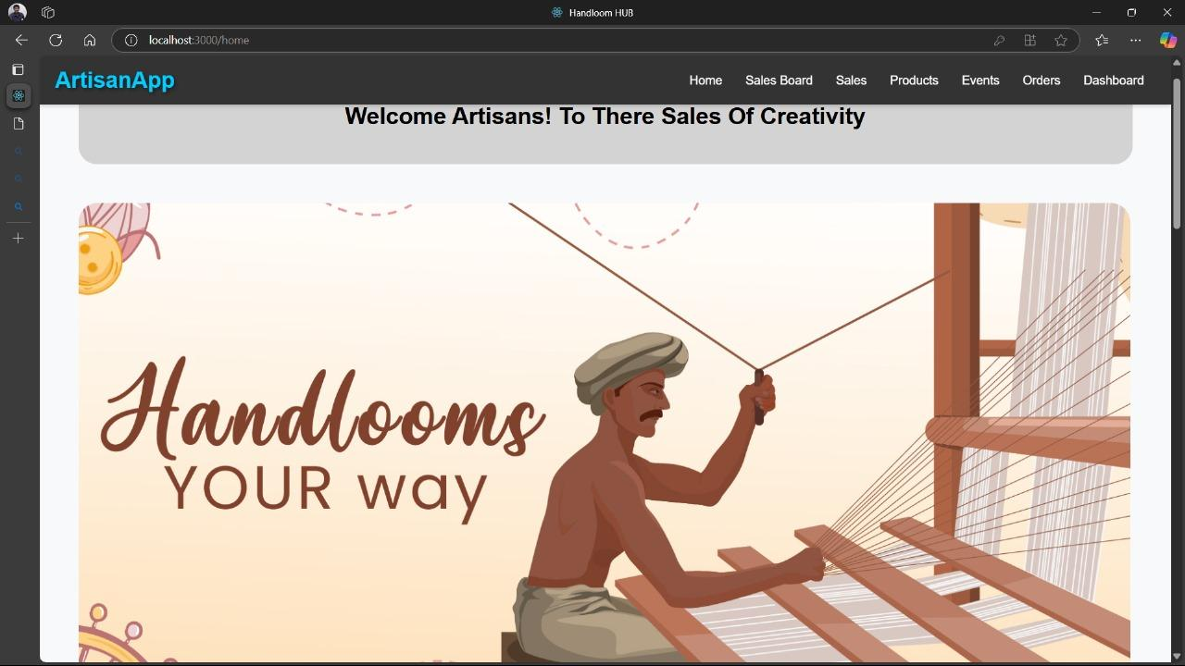

**Login Page**

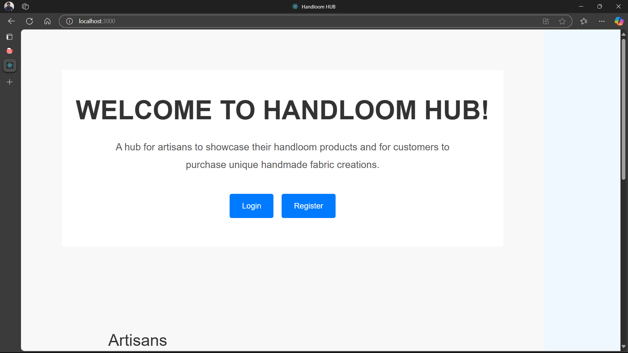

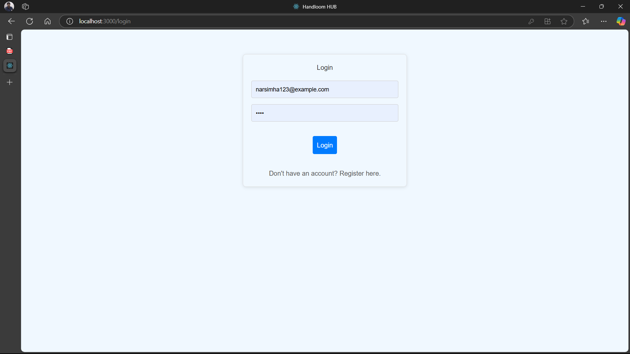

**Artisan Profile**

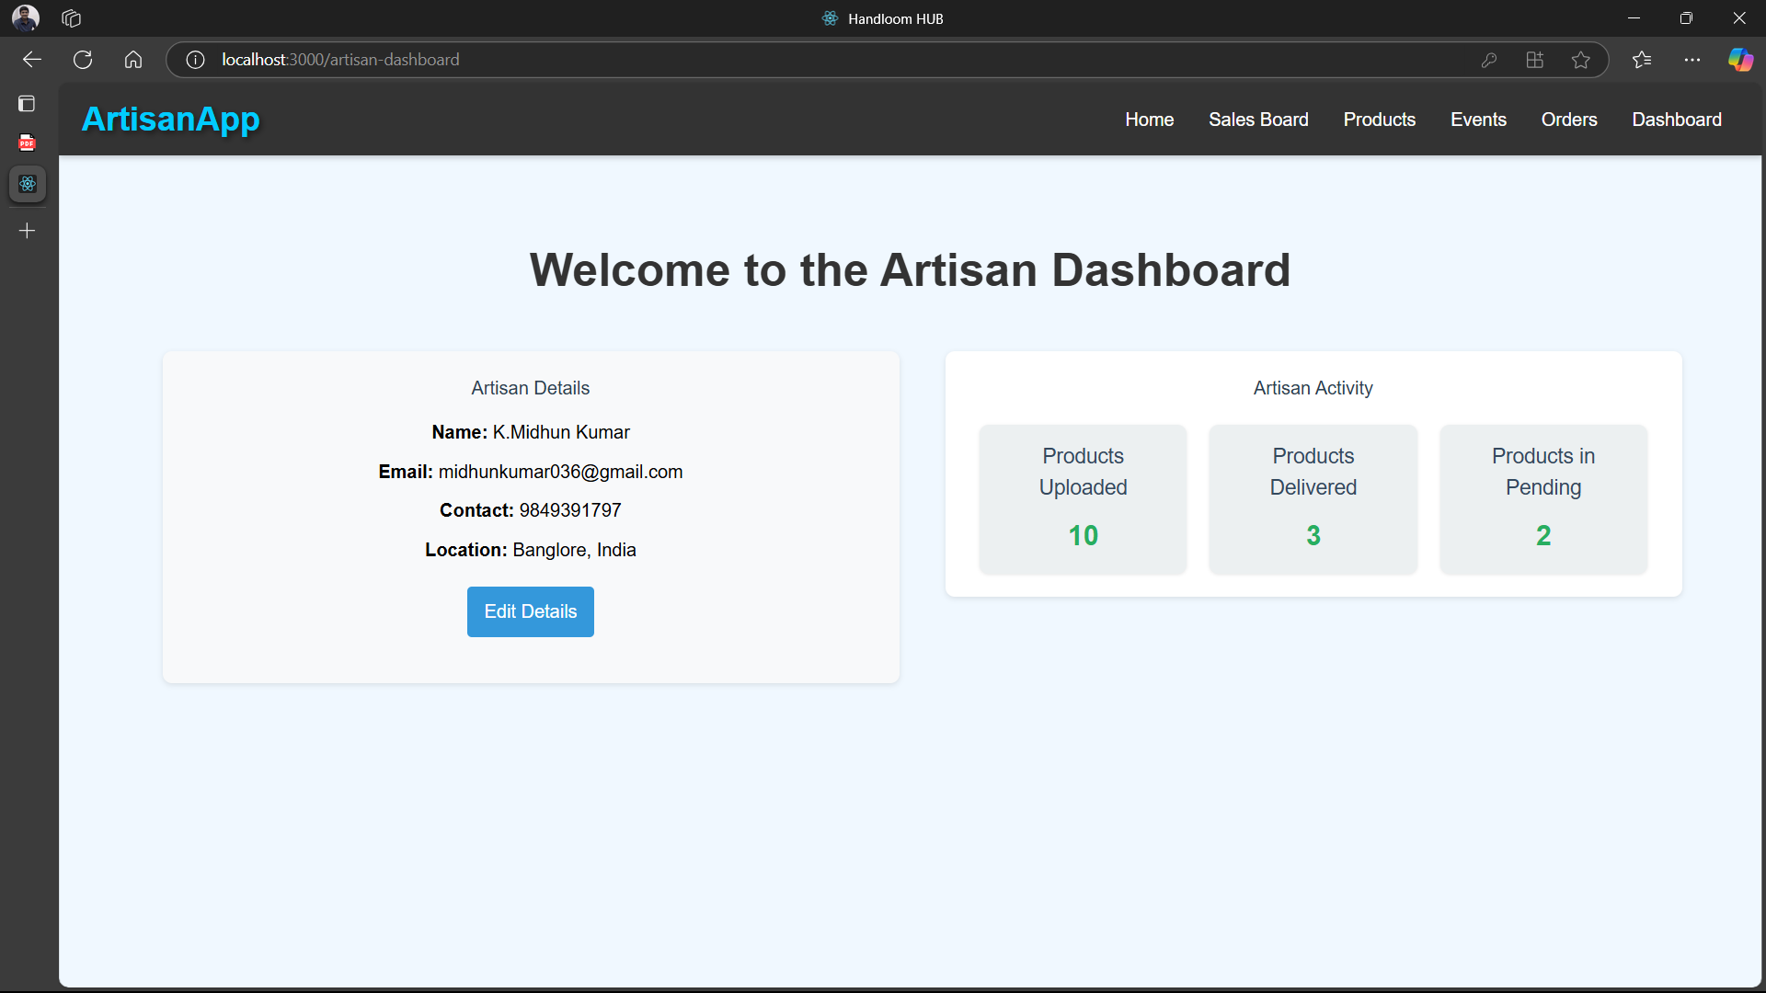

**Sales board**

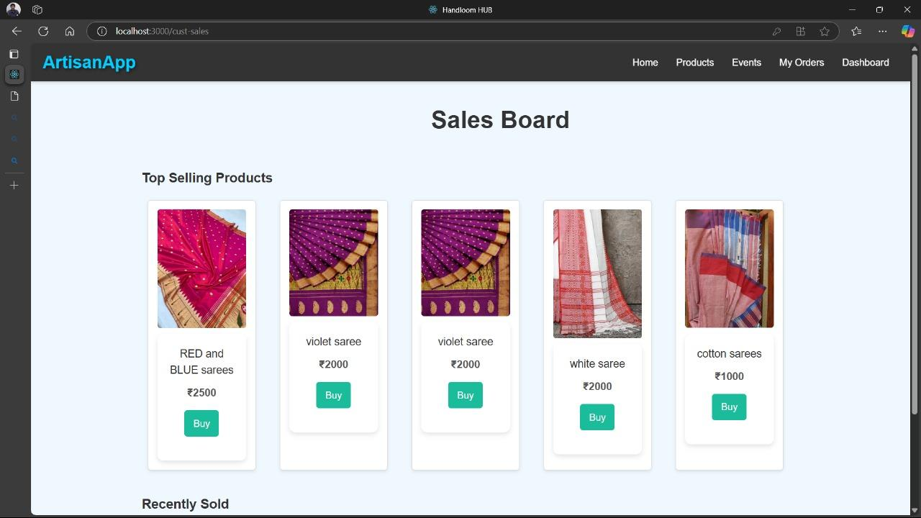

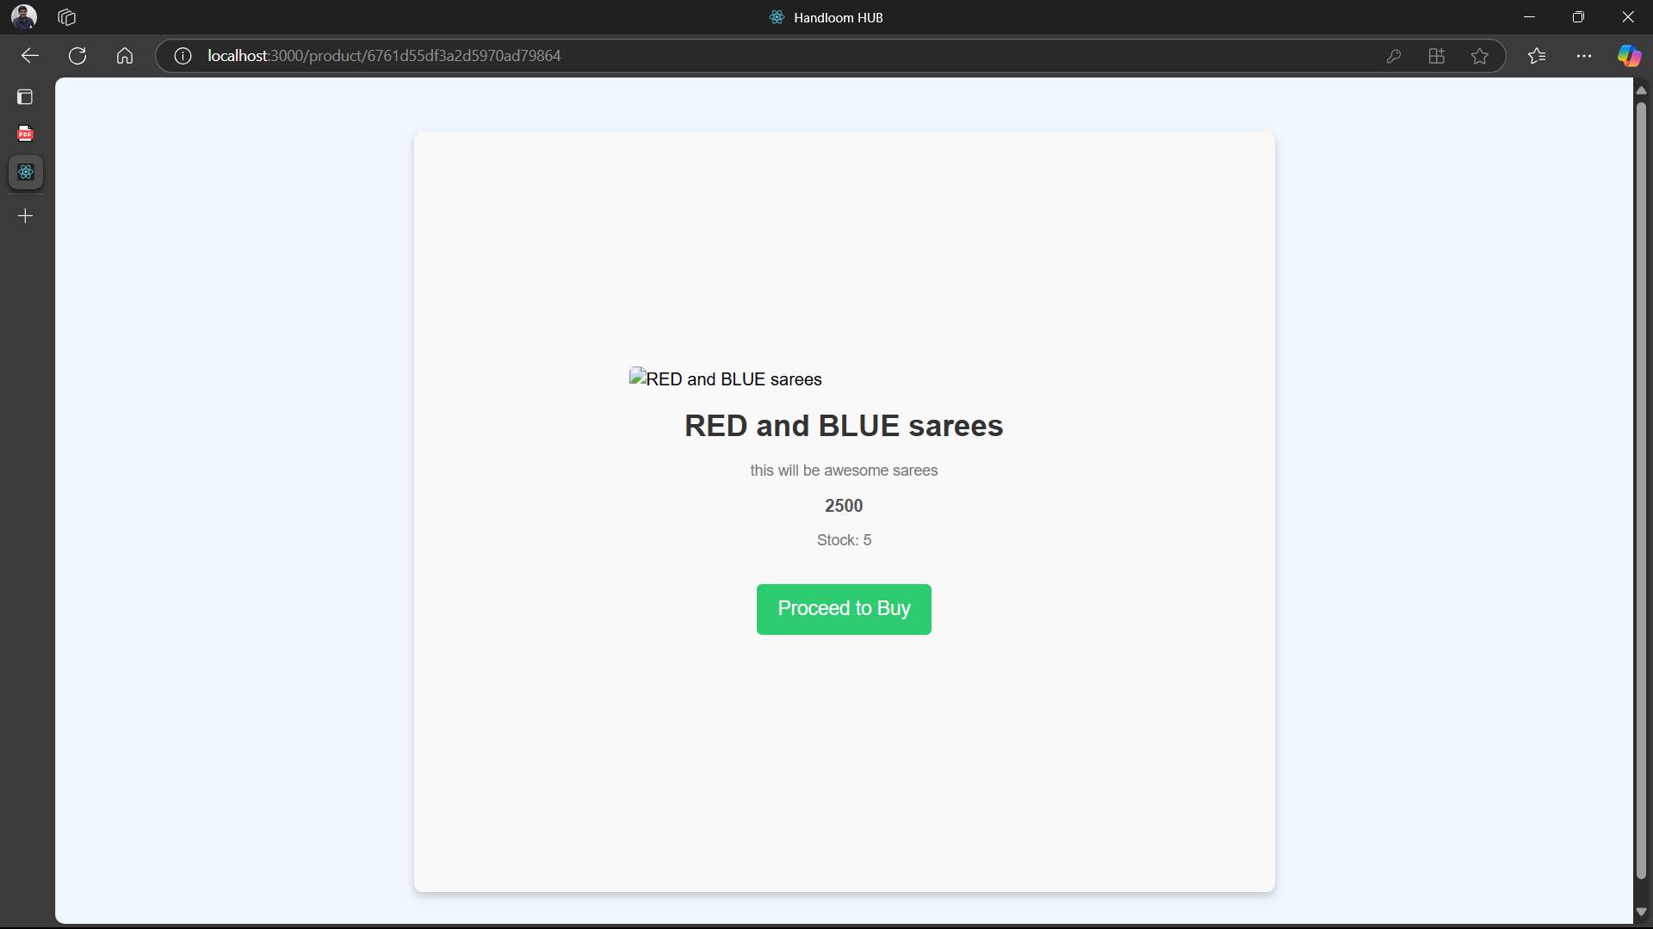

**Product management**

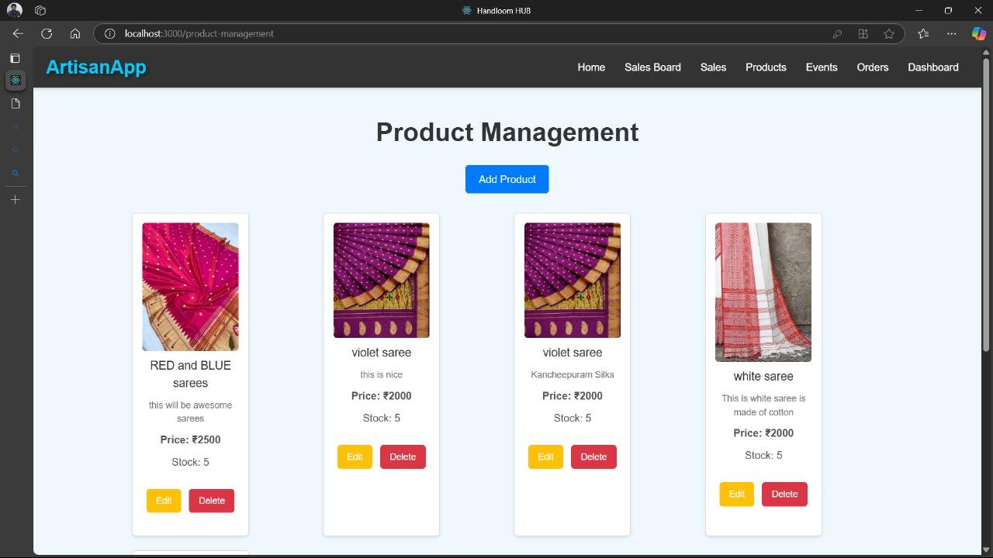

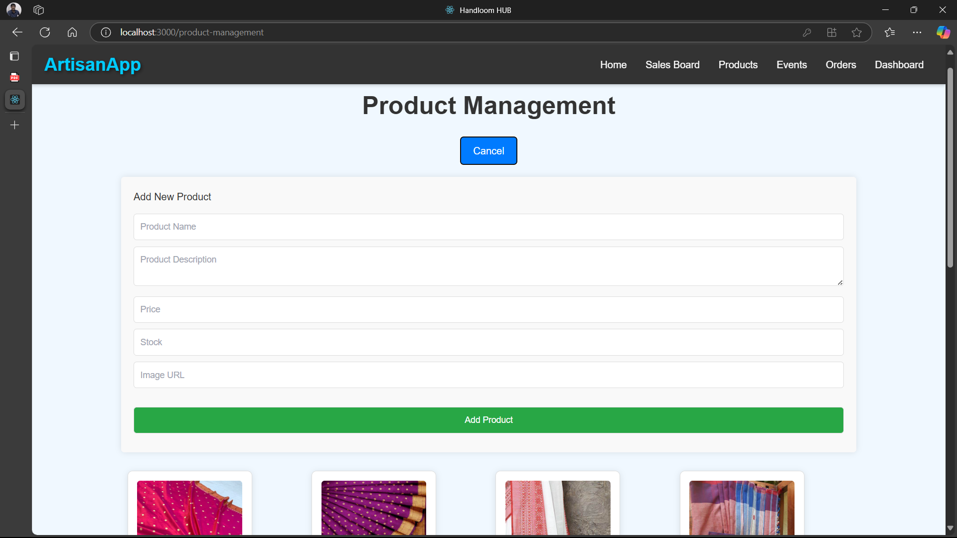

**Events page**

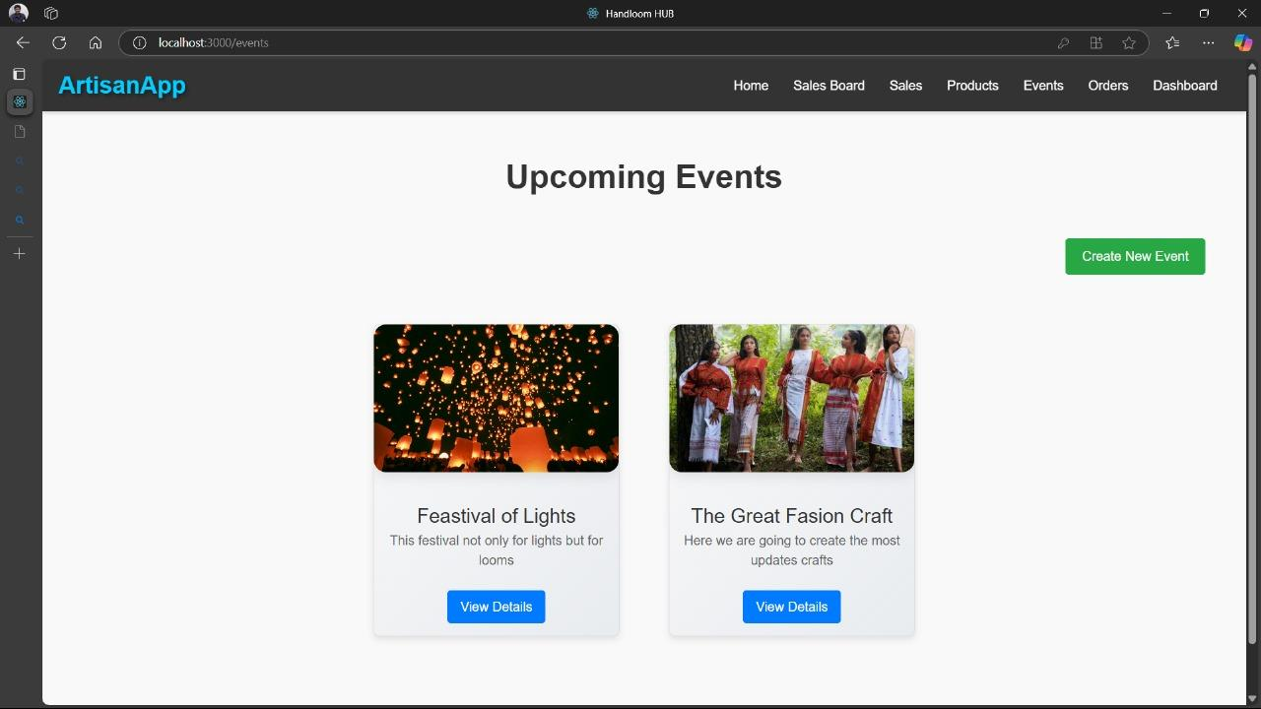

**Add Event Form**

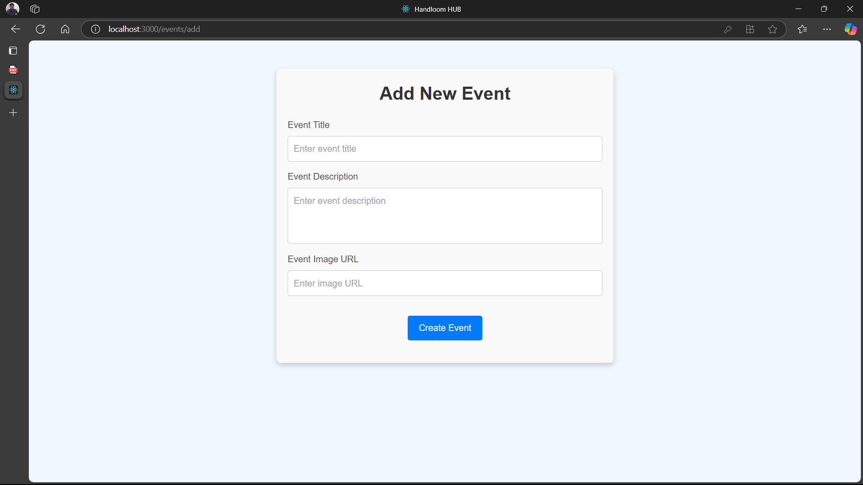

**Order page**

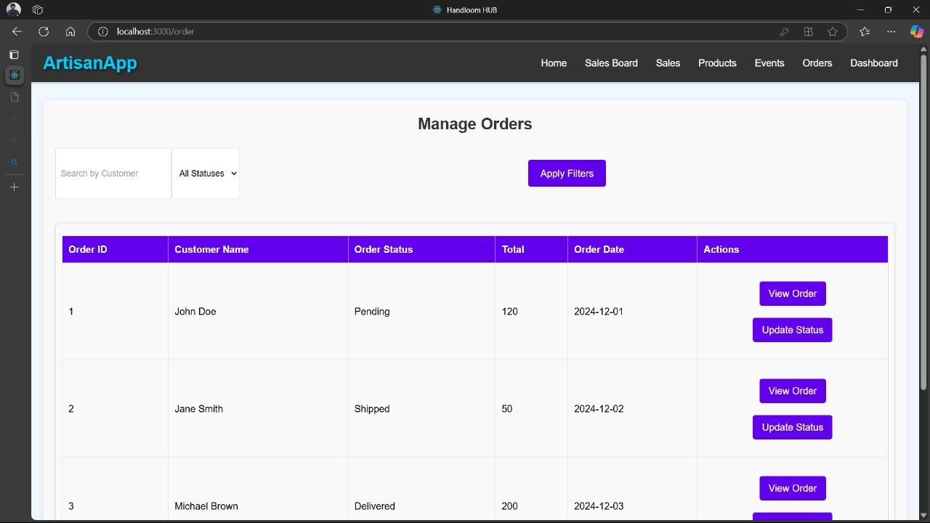

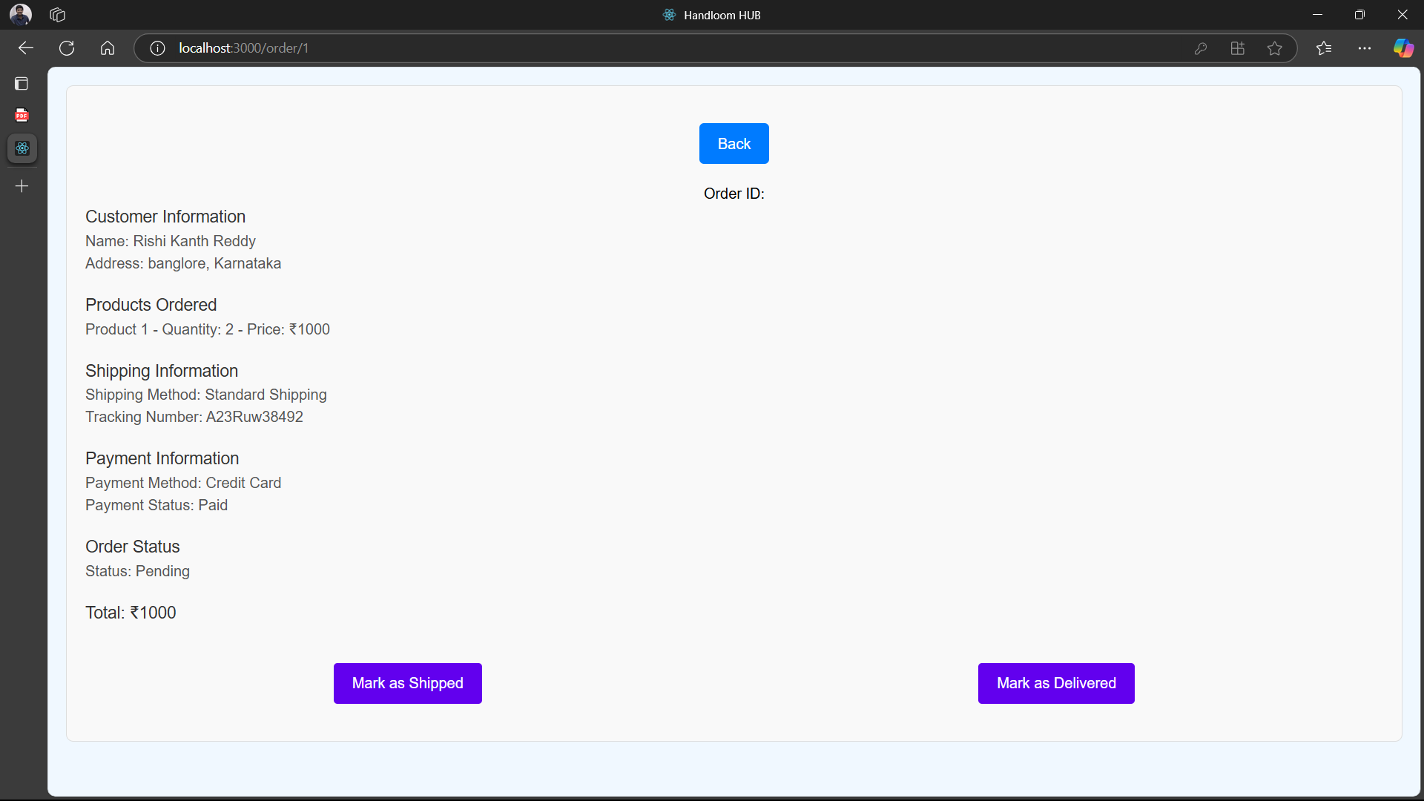

**Customer Profile**

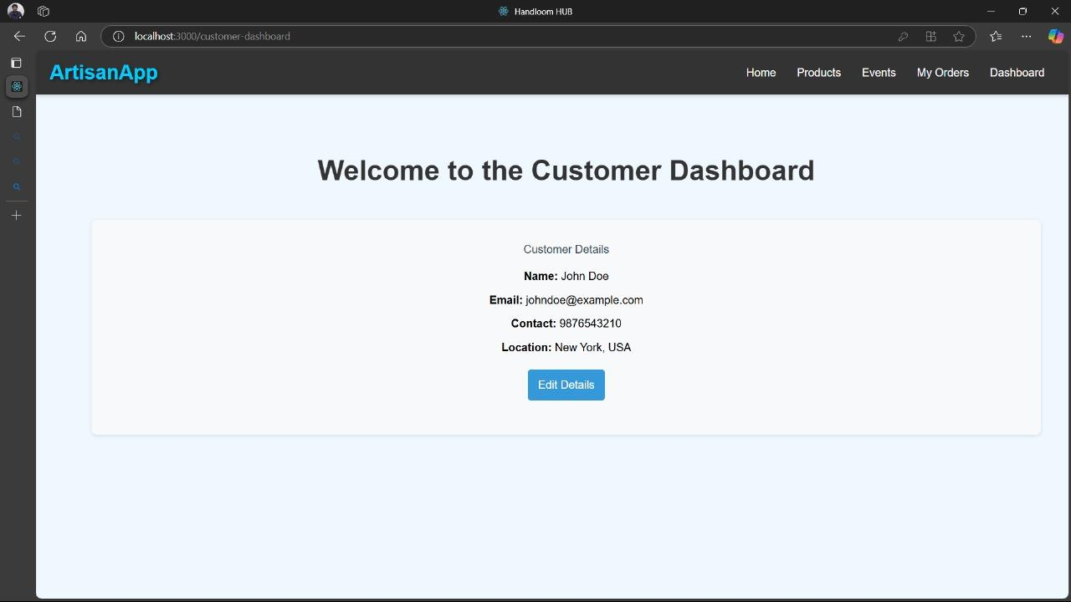

**Customer Event Page**

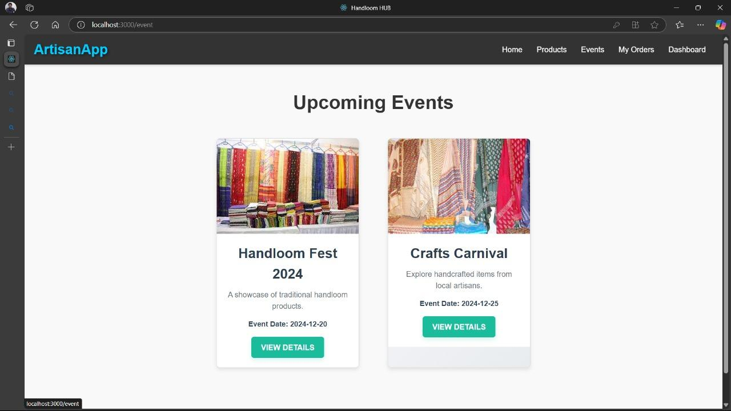

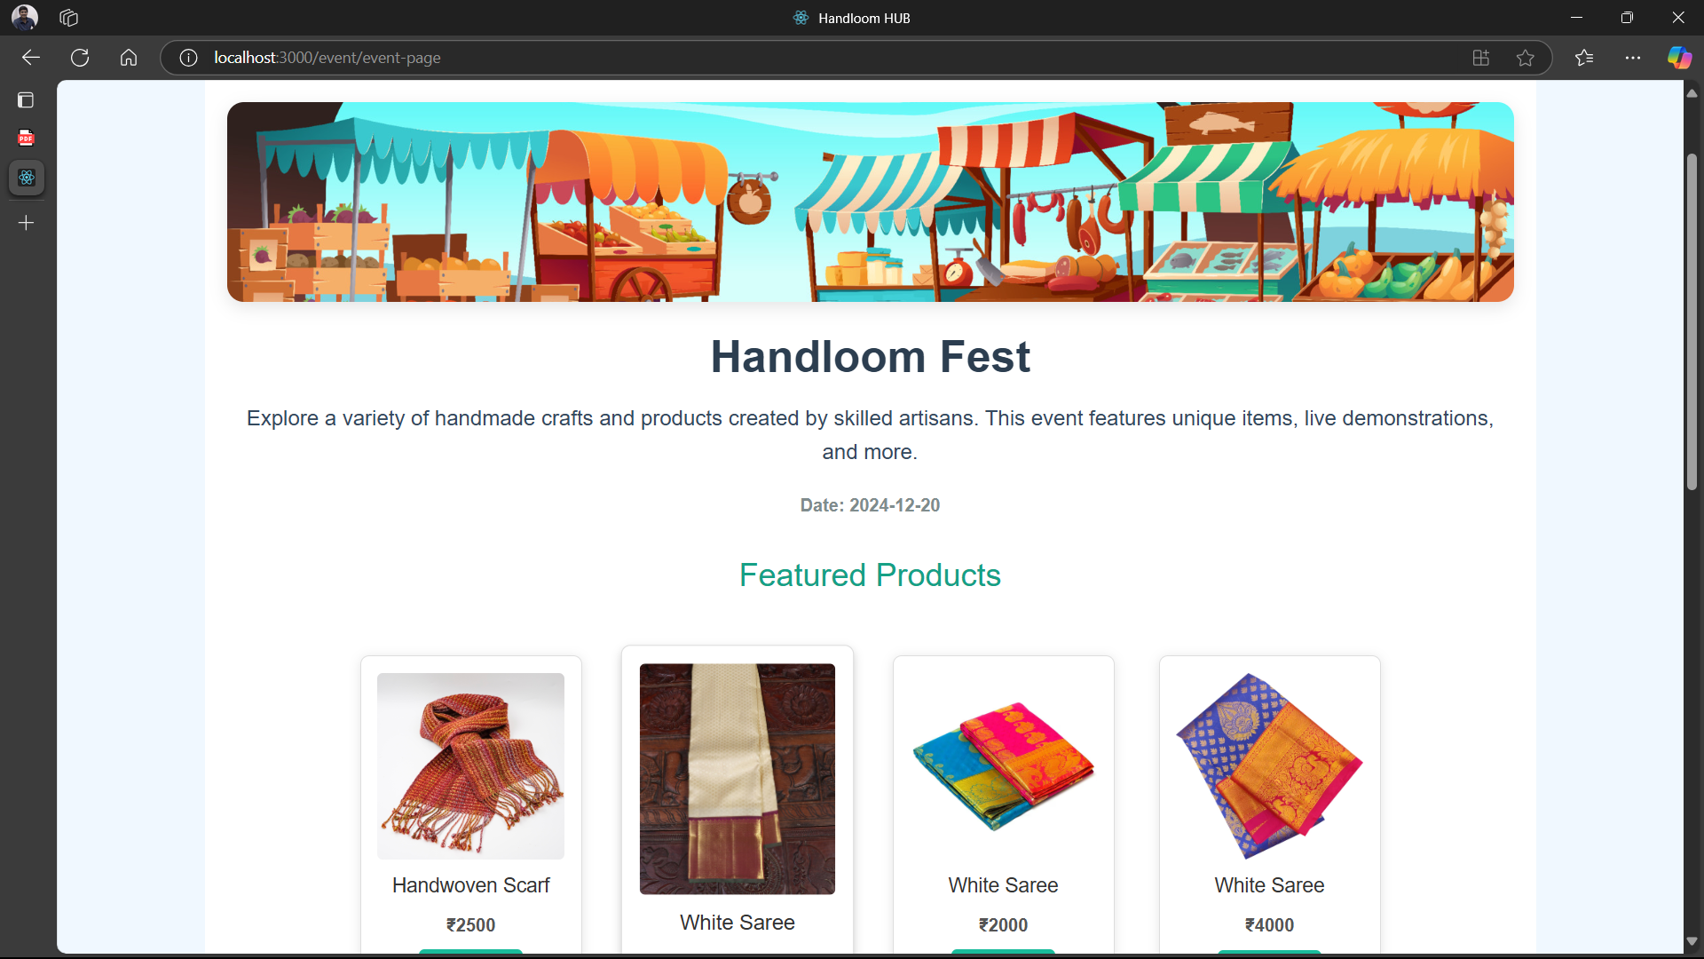

**Product Details**

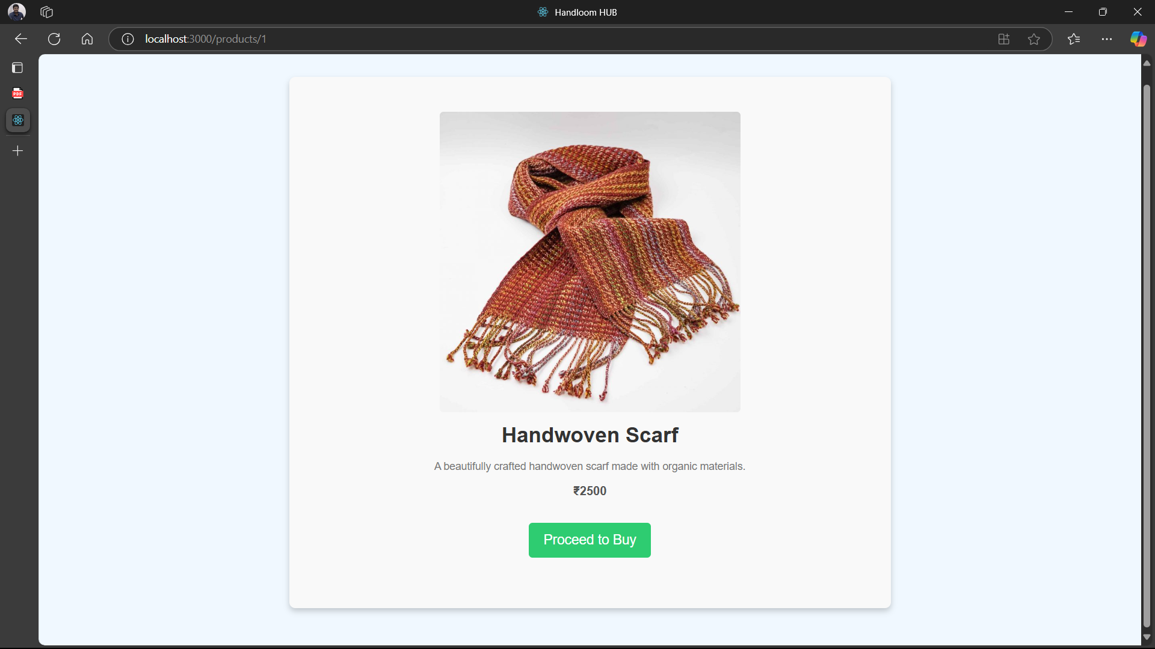

**Payment Form**

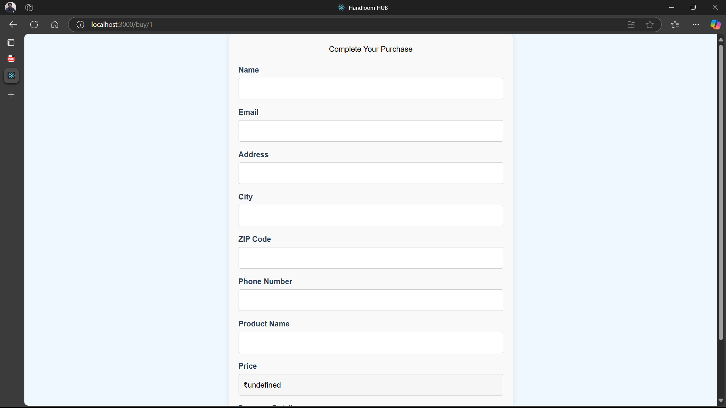

**Customer Orders**

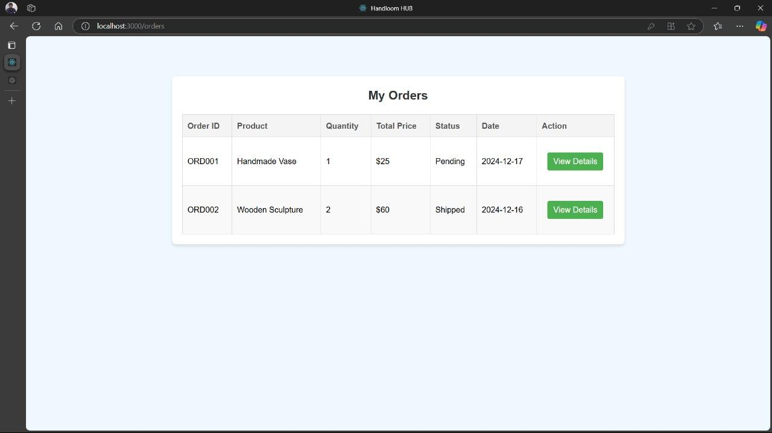

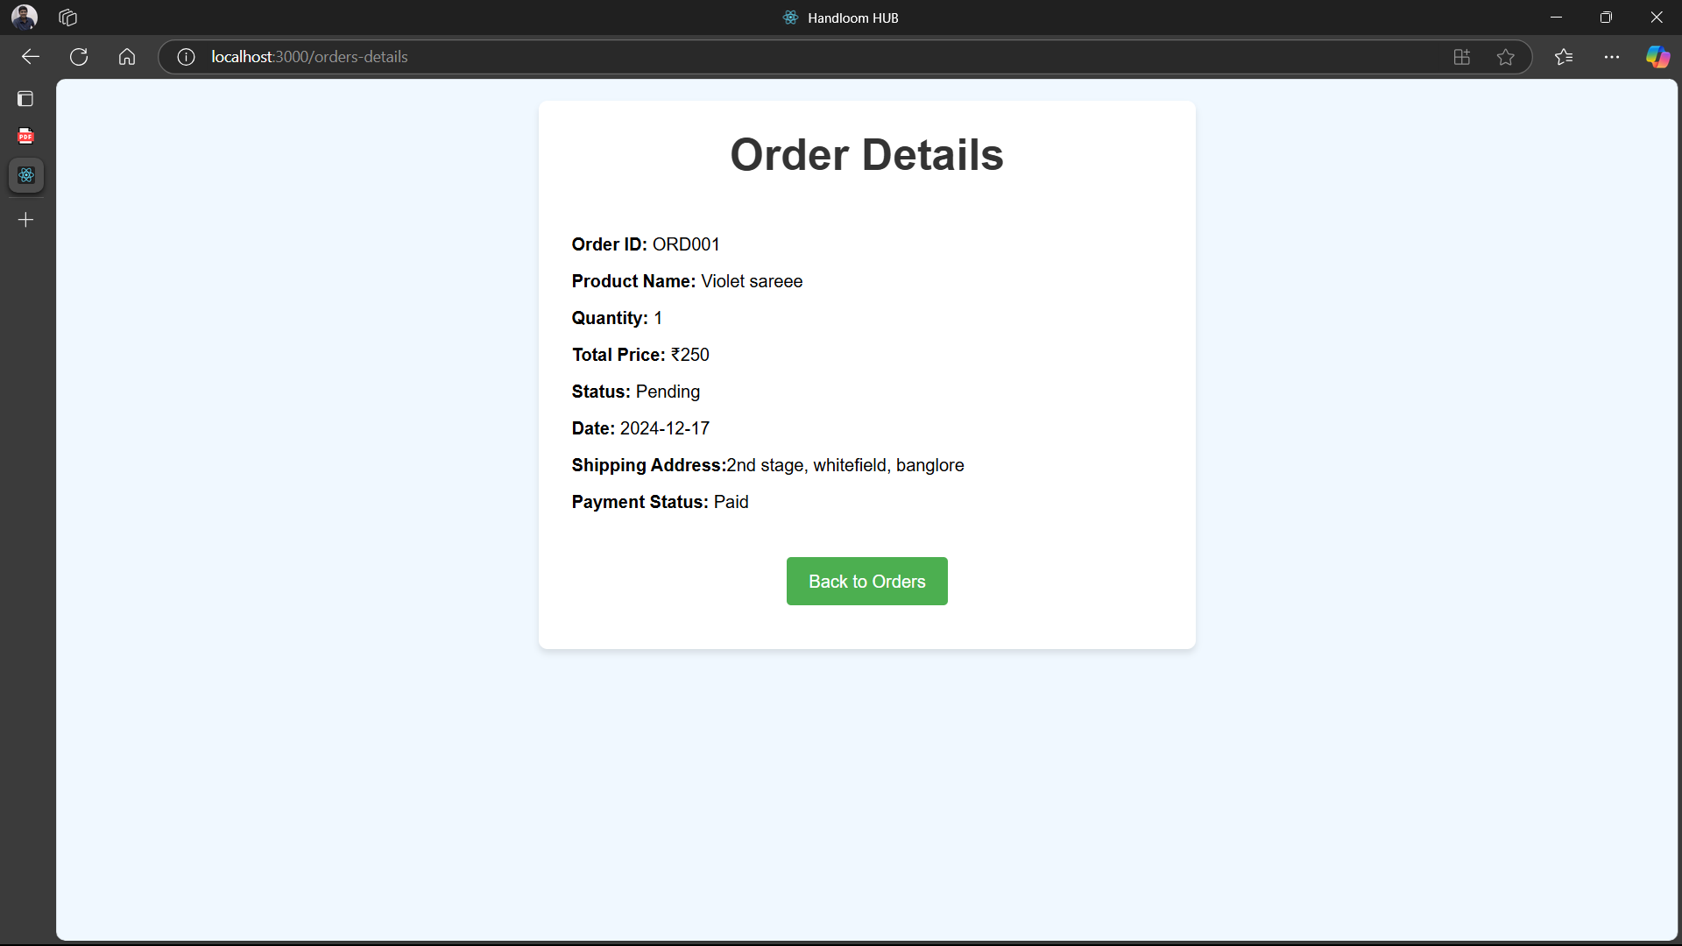

**APPENDIX -C**

1. **E-CERTIFICATES**

**Acceptance Certificate**



**K .Midhun Kumar**



**G Sunil Kumar Reddy**

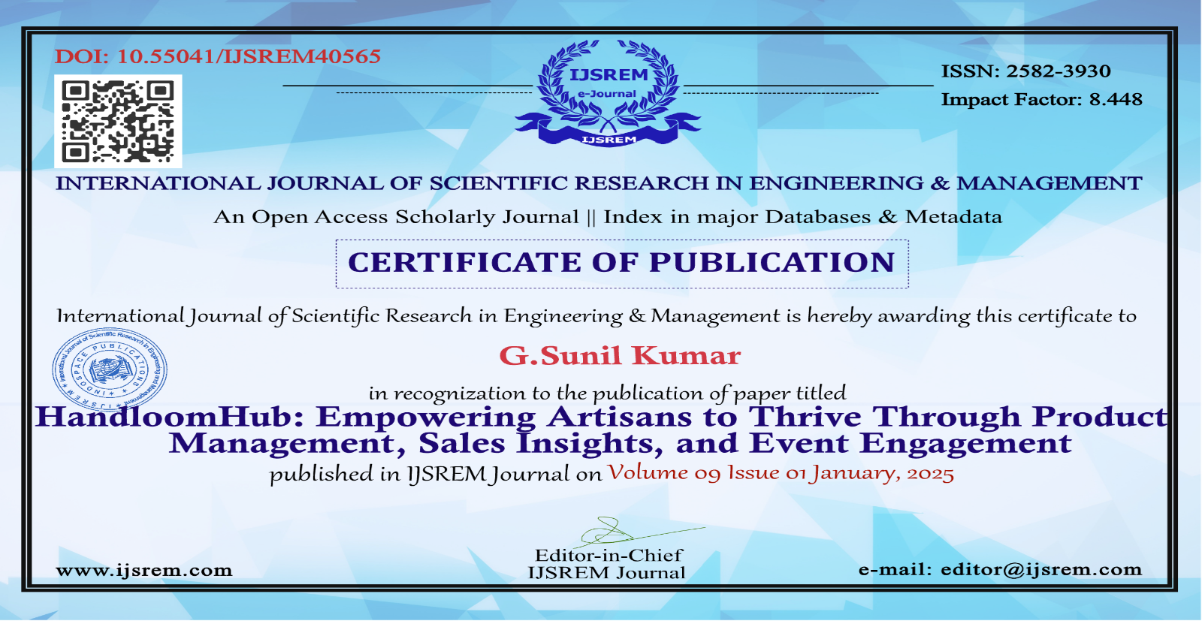

**Akash S**



**D. Venkata Narasimha Rao**



**S. Siva Anjaneyulu**



**2. Plagiarism Check report**



**3. Sustainable Development Goals**

**1. SDG 8: Decent Work and Economic Growth**

The project fosters economic empowerment by directly connecting artisans with broader markets, ensuring fair wages by reducing reliance on middlemen. Through business management tools like sales dashboards and inventory management, artisans can optimize production, track performance, and make data-driven decisions. By promoting entrepreneurship, the platform helps artisans achieve financial stability and independence, ultimately supporting sustainable livelihoods. This initiative encourages inclusive growth, targeting marginalized communities often dependent on small-scale industries.

**2. SDG 9: Industry, Innovation, and Infrastructure**

The project leverages technology to modernize small-scale industries, bridging the gap between artisans and consumers. By offering a digital platform, it supports innovation in traditional crafts, enabling artisans to showcase unique designs and experiment with creativity. Secure payment gateways and data analytics enhance user experience and business operations. The initiative strengthens the infrastructure for small-scale industries, fostering their inclusion in broader markets.

**3. SDG 11: Sustainable Cities and Communities**

This project encourages urban consumers to embrace sustainable consumption by purchasing handmade, locally crafted goods. By fostering a connection between artisans and urban markets, it preserves cultural heritage, helping sustain traditional crafts and skills. Artisans are empowered to thrive economically while maintaining their communities’ identity. Promoting eco-friendly, locally sourced products reduces the environmental impact associated with mass production and supports sustainable lifestyles.